**User Manual**

1.Open the application "Word Coater.exe".



2. The program will open.

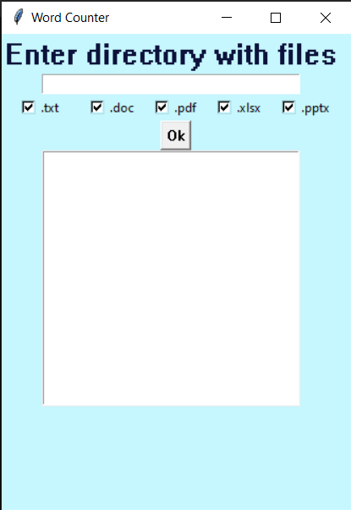

3. An open application should have: an input field, selected file formats for reading and an information field about the program's work performed.

4. In the input field, you must enter the path to the directory with the files you want to process.

Example:

*C:\Users\09leb\Desktop\Testtxt*

You can find out the path to the catalog if you go into it.

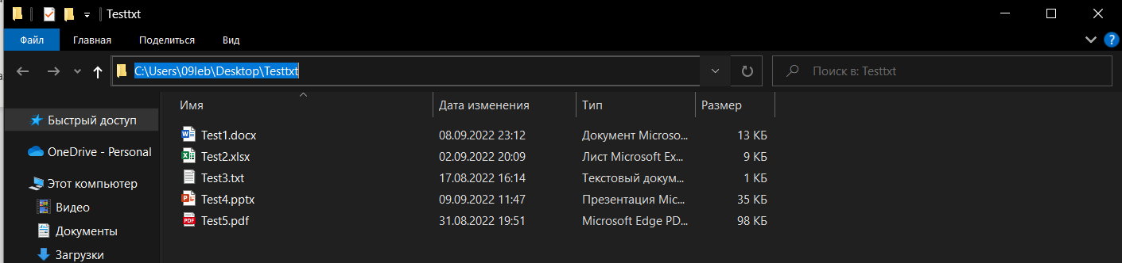

5. Choose the file format you want to use.

6. Click "OK" button.



7. After pressing the button in the information field, you will see information about the work performed by the program (what files it processed and where the report is located).

8. The report is saved in the same directory where the files were located but in the "Report Catalog" folder. The folder "Report Catalog" does not need to be created, it will be created automatically or if it already exists, the report will appear in it. The report is saved in .xlsx format with the name "Report", after the name there may be a number if this name is taken.

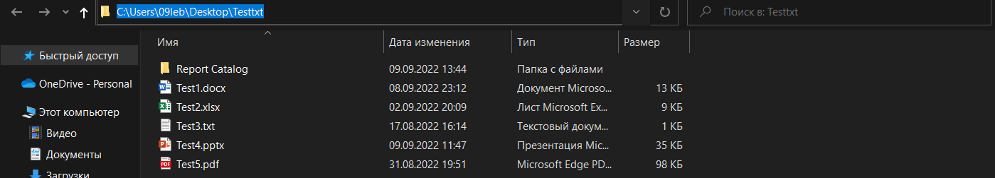

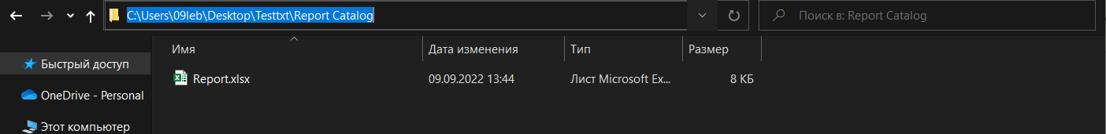

9. On the first page of the report, you will see what files were used, the date and time when the report was created.

10. The second page contains a list of words and the number of occurrences of each word in the selected files.

